Robust clipped correlation: AUDUSD and USDJPY
Method 04 / daily log returns clipped at ±0.01, ±0.02, ±0.03 / Alpari D1 full available history

Study setup
Logical pair: AUDUSD , USDJPY
Broker symbols: AUDUSD_i , USDJPY_i
Snapshot: 2026-11-03_majors_alpari_D1
Timeframe: D1
Matched return window: 1999-01-05 to 2026-11-02 (UTC bar dates)
Matched return count n: 7199
Dropped unfinished last bar dated 2026-11-03 UTC after a tick-volume check against the prior complete day.
Clip bounds c in log-return units: 0.01, 0.02, 0.03 (about ±1%, ±2%, ±3% on the log scale). Headline c = 0.02.
Clipping caps a day's magnitude at ±c and keeps the row; it does not drop the day, so n is the same at every c.
Complete matched rows (Excel): AUDUSD-USDJPY_Clipped_D1.xlsx
Complete matched rows (HTML table): AUDUSD-USDJPY_Clipped_D1_data.html

Method carried forward
Each matched daily log return of close, ln(close_t / close_t-1), is clipped in the broker quote direction before Pearson correlation: x_tilde = min(c, max(-c, x)) and y_tilde = min(c, max(-c, y)), then rho_clip = Pearson(x_tilde, y_tilde) on the same rows as raw Pearson r. Quotes are not inverted. A day beyond ±c stays in the sample at the cap; n does not change. rho_clip is symmetric under swap of the two symbols. rho_clip = 0 means no straight-line link among the clipped values in this sample; it does not mean no link of any kind. The score is not a cause, not a lead, and not a trading signal. Daily rows are not independent draws, so the two-sided p-value and Fisher interval are reported and treated as secondary to rho_clip. Cap-hit counts (|log return| > c) flag how much of each leg was capped.

Raw Pearson on the same rows
Pearson r: -0.088151
Two-sided p-value: 6.75242e-14
Approximate 95% Fisher interval: [-0.111025, -0.065183]
This is the unclipped comparison required by the method. The headline score is rho_clip at c = 0.02 below.

Clipped results
n = 7199 at every c. Headline row is c = 0.02. Cap-hit count is the number of days with |log return| > c before clipping.
c | rho_clip | p | ci_low | ci_high | rho_minus_r | AUDUSD_cap_hits | USDJPY_cap_hits | AUDUSD_cap_share | USDJPY_cap_share
0.01 | -0.202027 | 3.4844359e-67 | -0.22408231 | -0.17976565 | -0.11387679 | 978 | 646 | 0.135852 | 0.089735
0.02 | -0.157789 | 2.3476066e-41 | -0.1802326 | -0.13518088 | -0.06963825 | 130 | 75 | 0.018058 | 0.010418
0.03 | -0.130359 | 1.1718975e-28 | -0.15299924 | -0.10758254 | -0.042208674 | 34 | 17 | 0.004723 | 0.002361

Conclusion
Over 7199 matched daily log-return rows for AUDUSD and USDJPY (broker quote directions unchanged), headline robust clipped correlation at c=0.02 is -0.1578 (negative, weak straight-line association among clipped values in this sample). Approximate 95% Fisher interval on the clipped series: [-0.1802, -0.1352]. Same-sample raw Pearson r is -0.0882 (rho_clip minus r = -0.0696). Sensitivity across the fixed grid: c=0.01 same sign; c=0.02 same sign; c=0.03 same sign. Two-sided p under the usual independent bivariate-normal model is 2.348e-41; that model does not match linked daily FX returns, so treat p as secondary. The |rho_clip minus r| gap of -0.0696 is large enough to warrant reading the cap hits (AUDUSD=130, USDJPY=75 at c=0.02) before treating either score as settled. This does not establish cause, lead-lag, or a lasting trading rule.

What to look at in this file next time
1) rho_clip at c = 0.02 versus raw Pearson r. 2) Whether c = 0.01 and c = 0.03 keep the same sign as 0.02. 3) Cap-hit counts before treating a large gap as settled. 4) The ±0.02 lines on the returns chart and the clip box on the scatter.

Charts
Daily closes

Daily log returns with +/- 0.02 clip lines
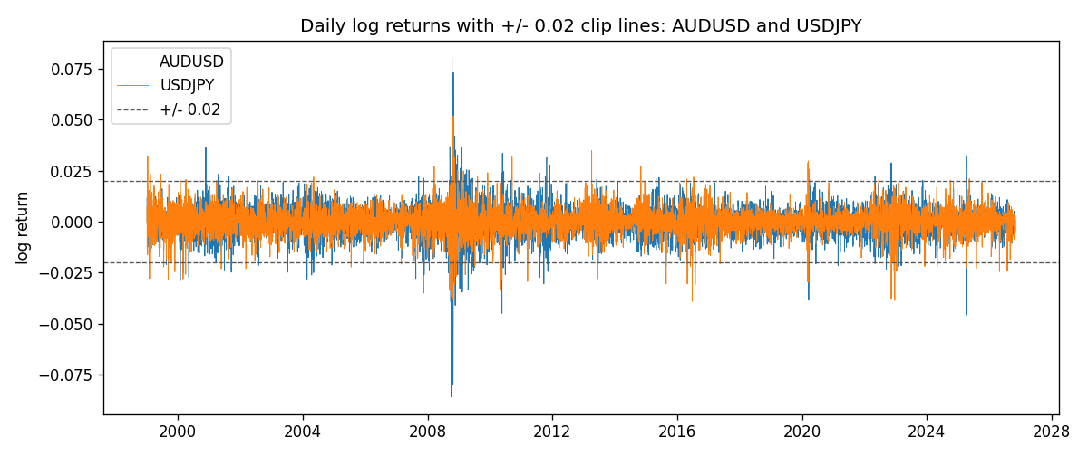
Log-return scatter with +/- 0.02 clip box
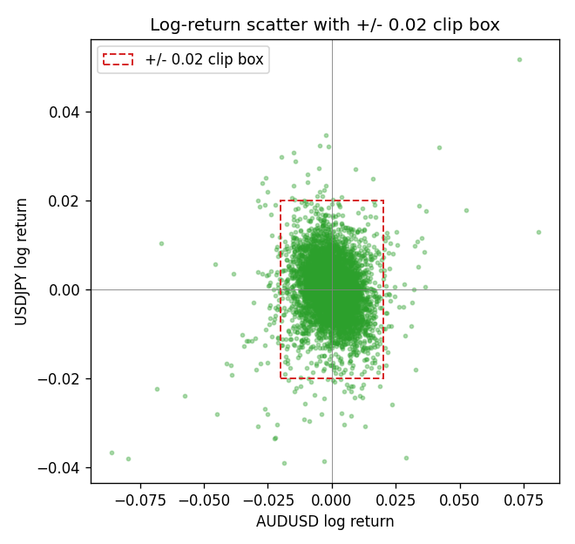

Data report
Every matched row that entered the clipped and raw correlations is stored in the sibling Excel workbook named AUDUSD-USDJPY_Clipped_D1.xlsx. That file is the complete data archive for redrawing charts. Embedding all rows as a Word table is impractical at this length; the Word file holds the column list, column summaries, and the first and last 15 matched rows.
Columns: time, AUDUSD_open, USDJPY_open, AUDUSD_high, USDJPY_high, AUDUSD_low, USDJPY_low, AUDUSD_close, USDJPY_close, AUDUSD_tick_volume, USDJPY_tick_volume, AUDUSD_spread, USDJPY_spread, AUDUSD_real_volume, USDJPY_real_volume, AUDUSD_log_return, USDJPY_log_return, AUDUSD_log_return_clip_0p01, USDJPY_log_return_clip_0p01, AUDUSD_log_return_clip_0p02, USDJPY_log_return_clip_0p02, AUDUSD_log_return_clip_0p03, USDJPY_log_return_clip_0p03
Column summaries (matched calculation rows)
column | count | mean | std | min | 25% | 50% | 75% | max
AUDUSD_open | 7199 | 0.75196998 | 0.13527571 | 0.4785 | 0.661035 | 0.73142 | 0.809135 | 1.10284
USDJPY_open | 7199 | 113.81114 | 19.206896 | 75.693 | 104.4285 | 110.984 | 120.6925 | 163.824
AUDUSD_high | 7199 | 0.75602148 | 0.13583632 | 0.4878 | 0.6647 | 0.7349 | 0.815325 | 1.10795
USDJPY_high | 7199 | 114.30872 | 19.268446 | 76.001 | 104.881 | 111.442 | 121.26 | 163.978
AUDUSD_low | 7199 | 0.7479145 | 0.13459018 | 0.4775 | 0.6577 | 0.72758 | 0.80425 | 1.0975
USDJPY_low | 7199 | 113.28779 | 19.134887 | 75.402 | 103.89 | 110.53 | 120.17 | 163.628
AUDUSD_close | 7199 | 0.75202255 | 0.13525884 | 0.4786 | 0.661195 | 0.73175 | 0.809235 | 1.10169
USDJPY_close | 7199 | 113.824 | 19.222288 | 75.811 | 104.42 | 111.025 | 120.687 | 163.851
AUDUSD_tick_volume | 7199 | 77366.826 | 138149.99 | 109 | 5440 | 43349 | 71344.5 | 1234623
USDJPY_tick_volume | 7199 | 106151.62 | 179316.41 | 197 | 9927 | 53098 | 92761 | 1803508
AUDUSD_spread | 7199 | 30.814558 | 16.886804 | 0 | 13 | 30 | 50 | 50
USDJPY_spread | 7199 | 20.321434 | 17.631726 | 0 | 6 | 11 | 30 | 50
AUDUSD_real_volume | 7199 | 5.2435469e+09 | 1.2539788e+11 | 0 | 0 | 0 | 0 | 3.811512e+12
USDJPY_real_volume | 7199 | 3.470603e+10 | 1.6078743e+11 | 0 | 0 | 0 | 0 | 3.8834203e+12
AUDUSD_log_return | 7199 | 2.78e-05 | 0.00754502 | -0.08602525 | -0.00385397 | 0.00028846 | 0.00415332 | 0.0806166
USDJPY_log_return | 7199 | 4.761e-05 | 0.00620532 | -0.03908203 | -0.00320306 | 0.00011368 | 0.00340781 | 0.05184024
AUDUSD_log_return_clip_0p01 | 7199 | 0.00011816 | 0.00565301 | -0.01 | -0.00385397 | 0.00028846 | 0.00415332 | 0.01
USDJPY_log_return_clip_0p01 | 7199 | 9.071e-05 | 0.00508614 | -0.01 | -0.00320306 | 0.00011368 | 0.00340781 | 0.01
AUDUSD_log_return_clip_0p02 | 7199 | 6.174e-05 | 0.00682378 | -0.02 | -0.00385397 | 0.00028846 | 0.00415332 | 0.02
USDJPY_log_return_clip_0p02 | 7199 | 6.529e-05 | 0.00593071 | -0.02 | -0.00320306 | 0.00011368 | 0.00340781 | 0.02
AUDUSD_log_return_clip_0p03 | 7199 | 4.453e-05 | 0.00713369 | -0.03 | -0.00385397 | 0.00028846 | 0.00415332 | 0.03
USDJPY_log_return_clip_0p03 | 7199 | 4.988e-05 | 0.00613883 | -0.03 | -0.00320306 | 0.00011368 | 0.00340781 | 0.03
First 15 matched rows (selected columns)
time | AUDUSD_close | USDJPY_close | AUDUSD_log_return | USDJPY_log_return | AUDUSD_log_return_clip_0p02 | USDJPY_log_return_clip_0p02
1999-01-05 | 0.6215 | 111.92 | -0.00080418179 | -0.00017868311 | -0.00080418179 | -0.00017868311
1999-01-06 | 0.6289 | 112.77 | 0.011836351 | 0.0075660159 | 0.011836351 | 0.0075660159
1999-01-07 | 0.6345 | 111.33 | 0.0088650256 | -0.012851583 | 0.0088650256 | -0.012851583
1999-01-08 | 0.6347 | 110.8 | 0.00031515916 | -0.0047719894 | 0.00031515916 | -0.0047719894
1999-01-11 | 0.6393 | 109.02 | 0.0072213815 | -0.016195423 | 0.0072213815 | -0.016195423
1999-01-12 | 0.6362 | 112.6 | -0.0048608485 | 0.032310364 | -0.0048608485 | 0.02
1999-01-13 | 0.6312 | 113.52 | -0.0078902098 | 0.0081373171 | -0.0078902098 | 0.0081373171
1999-01-14 | 0.6295 | 113.52 | -0.002696916 | 0 | -0.002696916 | 0
1999-01-15 | 0.634 | 114.15 | 0.007123101 | 0.0055343401 | 0.007123101 | 0.0055343401
1999-01-18 | 0.6346 | 114.16 | 0.00094592471 | 8.7600193e-05 | 0.00094592471 | 8.7600193e-05
1999-01-19 | 0.6392 | 113.52 | 0.0072225153 | -0.0056219403 | 0.0072225153 | -0.0056219403
1999-01-20 | 0.64 | 112.91 | 0.0012507819 | -0.0053879917 | 0.0012507819 | -0.0053879917
1999-01-21 | 0.6405 | 113.87 | 0.00078094498 | 0.0084664056 | 0.00078094498 | 0.0084664056
1999-01-22 | 0.6327 | 114.56 | -0.012252745 | 0.0060412564 | -0.012252745 | 0.0060412564
1999-01-25 | 0.6302 | 113.72 | -0.0039591468 | -0.0073594164 | -0.0039591468 | -0.0073594164
Last 15 matched rows (selected columns)
time | AUDUSD_close | USDJPY_close | AUDUSD_log_return | USDJPY_log_return | AUDUSD_log_return_clip_0p02 | USDJPY_log_return_clip_0p02
2026-10-13 | 0.69821 | 158.305 | 0.0035007712 | -0.0018932826 | 0.0035007712 | -0.0018932826
2026-10-14 | 0.69715 | 158.317 | -0.0015193215 | 7.5800166e-05 | -0.0015193215 | 7.5800166e-05
2026-10-15 | 0.69191 | 158.024 | -0.0075447063 | -0.0018524319 | -0.0075447063 | -0.0018524319
2026-10-16 | 0.69426 | 157.964 | 0.0033906408 | -0.00037976126 | 0.0033906408 | -0.00037976126
2026-10-19 | 0.6978 | 158.517 | 0.0050859986 | 0.0034946841 | 0.0050859986 | 0.0034946841
2026-10-20 | 0.70022 | 158.16 | 0.0034620426 | -0.0022546642 | 0.0034620426 | -0.0022546642
2026-10-21 | 0.70275 | 158.108 | 0.0036066384 | -0.00032883504 | 0.0036066384 | -0.00032883504
2026-10-22 | 0.70186 | 156.755 | -0.0012672558 | -0.0085942669 | -0.0012672558 | -0.0085942669
2026-10-23 | 0.70353 | 156.81 | 0.0023765656 | 0.00035080446 | 0.0023765656 | 0.00035080446
2026-10-26 | 0.70128 | 157.458 | -0.0032032829 | 0.0041238746 | -0.0032032829 | 0.0041238746
2026-10-27 | 0.70245 | 157.894 | 0.0016669876 | 0.0027651658 | 0.0016669876 | 0.0027651658
2026-10-28 | 0.70533 | 157.743 | 0.0040915541 | -0.00095679538 | 0.0040915541 | -0.00095679538
2026-10-29 | 0.70245 | 157.683 | -0.0040915541 | -0.00038043789 | -0.0040915541 | -0.00038043789
2026-10-30 | 0.70316 | 157.516 | 0.0010102376 | -0.0010596481 | 0.0010102376 | -0.0010596481
2026-11-02 | 0.69971 | 157.933 | -0.0049184984 | 0.0026438521 | -0.0049184984 | 0.0026438521

